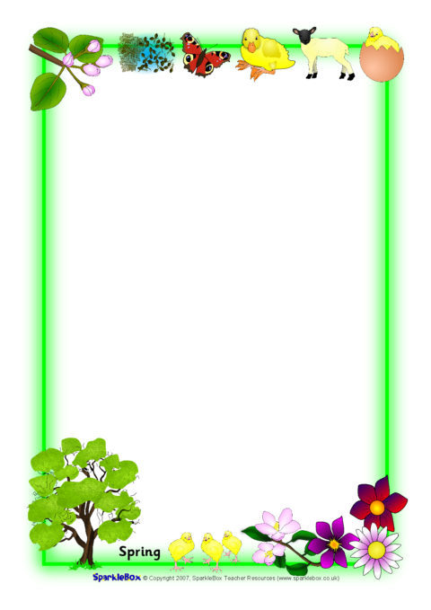

Sycamore Class Spring 2 newsletter.

Dear parents/carers,
Well, wasn’t Spring 1 a fast term! We hope you have had a restful break and we are excited about the upcoming half term! This half term in Sycamore class we will be focusing our learning around the topic of ‘Traditional tales’. The children will be immersed in learning with exciting stories such as ‘The Gingerbread man’, ‘Three little pigs’ and ‘Little Red Riding Hood’ to name a few! As always, all children will continue to participate in communication and phonics lessons, Literacy, Mathematics, Science and PSED sessions (along with many others!).
In mathematics this term, children will continue to work on their number skills and also look at ‘capacity’. The children have already had fun experimenting with the capacity of some containers in water play. It would be great if the children had a chance to practice using ‘capacity’ mathematical language at home too, perhaps when having a bath, to measure water in cups or to pour your family a drink to see who’s container holds more!
We are very lucky to be supported by a Student Teacher; Miss Wood. Miss Wood is now delivering lots of the children’s lessons; whilst being supported by Donna and Miss Harrison.
We will continue to have our PE lesson on a Thursday morning, and the children are excited to participate in ‘games’ sessions. We hope to start these sessions with lessons on ball games and ball skills! Please ensure your child has a named PE kit in school.
Please continue to use the home-school diaries or ring the school to communicate regularly to us, we love to hear about the learning children are doing at home too.
Best Wishes!
Miss Harrison, Donna and Miss Wood (Student teacher).

