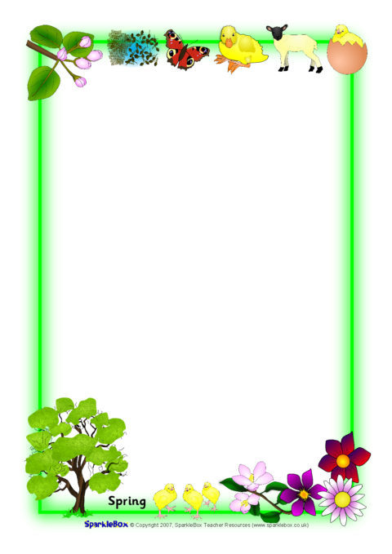

Sycamore Class Spring 1 newsletter.

Dear parents/carers,
We hope you have enjoyed a fantastic Christmas break and are ready to go for the New Year! This term in Sycamore class we will be focusing and basing our learning around the themes: ‘In the wild’ and ‘Traditional tales’. All children will continue to participate in communication and phonics lessons, Literacy, Mathematics, Science and PSED sessions (along with many others!).
In mathematics this term, children will continue to work on their number skills and also look at ‘size’ and ‘capacity’. Perhaps at home children could be encouraged to compare sizes of objects to one another (“Which toy is big? Which is small? Which is the biggest?”) and to play capacity games at bath time! (Is the cup empty or full? Which cup holds more water?).
The children also continue to participate in Forest School sessions – on a Tuesday morning. Pupils are free to come into school dressed in warm clothes (comfortable and clothes you don’t mind getting a little muddy) with school uniform in their bags ready to change into after the session. All children require wellies, which can be kept in school.
Please ensure your child has a named PE kit in school in time for our next PE lesson – Thursday. Thank you to you who have already done so.
We are very excited about all the great adventures we may have this Spring!
Please continue to use the home-school diaries or ring the school to communicate regularly to us.
Best Wishes!
Miss Harrison, Donna and Miss Wood (Student teacher).

