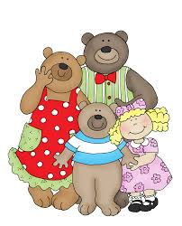
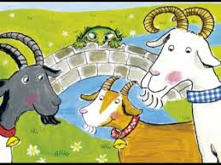

Spring 2 Class Newsletter

Dear Parents and Carers,

This half term our theme is ‘Traditional Tales’. Our learning is going to be based on a different traditional tale each week, including: Goldilocks and the Three Bears, The Three Billy Goats Gruff, The Gingerbread Man, The Three Little Pigs, Little Red Riding Hood and Jack and the Beanstalk. Through our literacy lessons, we will be learning to join in with repetitive phrases and identify characters and story setting. We will be engaging in lots of sensory story play, as well as story role play.

In our Maths learning, we will be continuing to develop our number skills, as well as further developing our knowledge of size and capacity. In other areas of learning, we will be learning about Pancake Day, Mother’s Day and Easter.

In our Understanding the World sessions, we will be investigating materials related to the traditional tales, including building different houses for the Three Little Pigs, and making a boat for the Gingerbread Man to cross the river to save him from being eaten by the fox!

Our PE learning this half term is ‘Games’. We will be developing our rolling, throwing, catching and kicking ball skills.

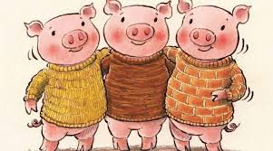
Keep checking Tapestry for all the wonderful things your child is doing!

Saplings Class Team

