

Rigby Lane, Bromsgrove, Worcestershire B60 2EP
Tel: 01527 875475 Fax: 01527 870211
Headteacher: Mrs T Smith
www.rigbyhallschool.com
Email – office@rigbyhall.worcs.sch.uk

25th February 2018
Dear Parents / Carers,

As we begin the second part of the spring term I just wanted to update you on what the pupils will be covering in their various subjects through to Easter. The first half of the spring term was a real positive one and it was lovely to finish with a trip to the recycle centre Envirosort in Worcester. Everyone really enjoyed the trip, as you can see from the photographs below, and we all learnt something about what we can and can’t recycle. The trip formed part of the hours we require to complete the ‘Me and My World’ section of our silver JASS Award.

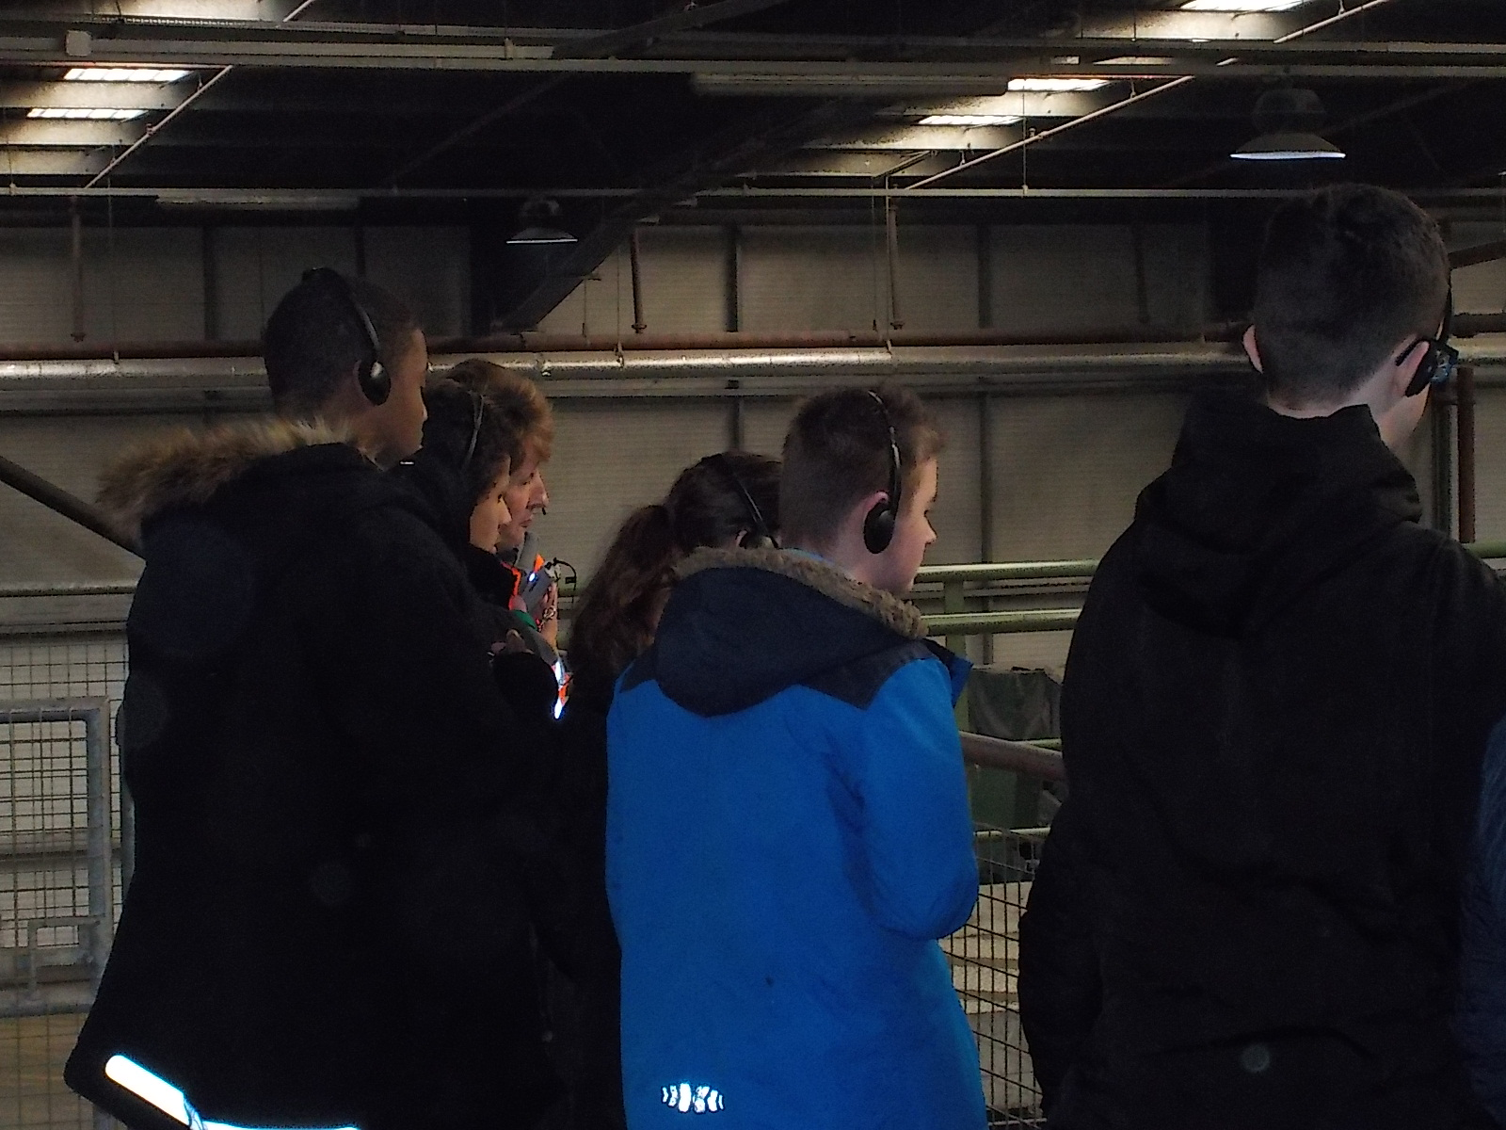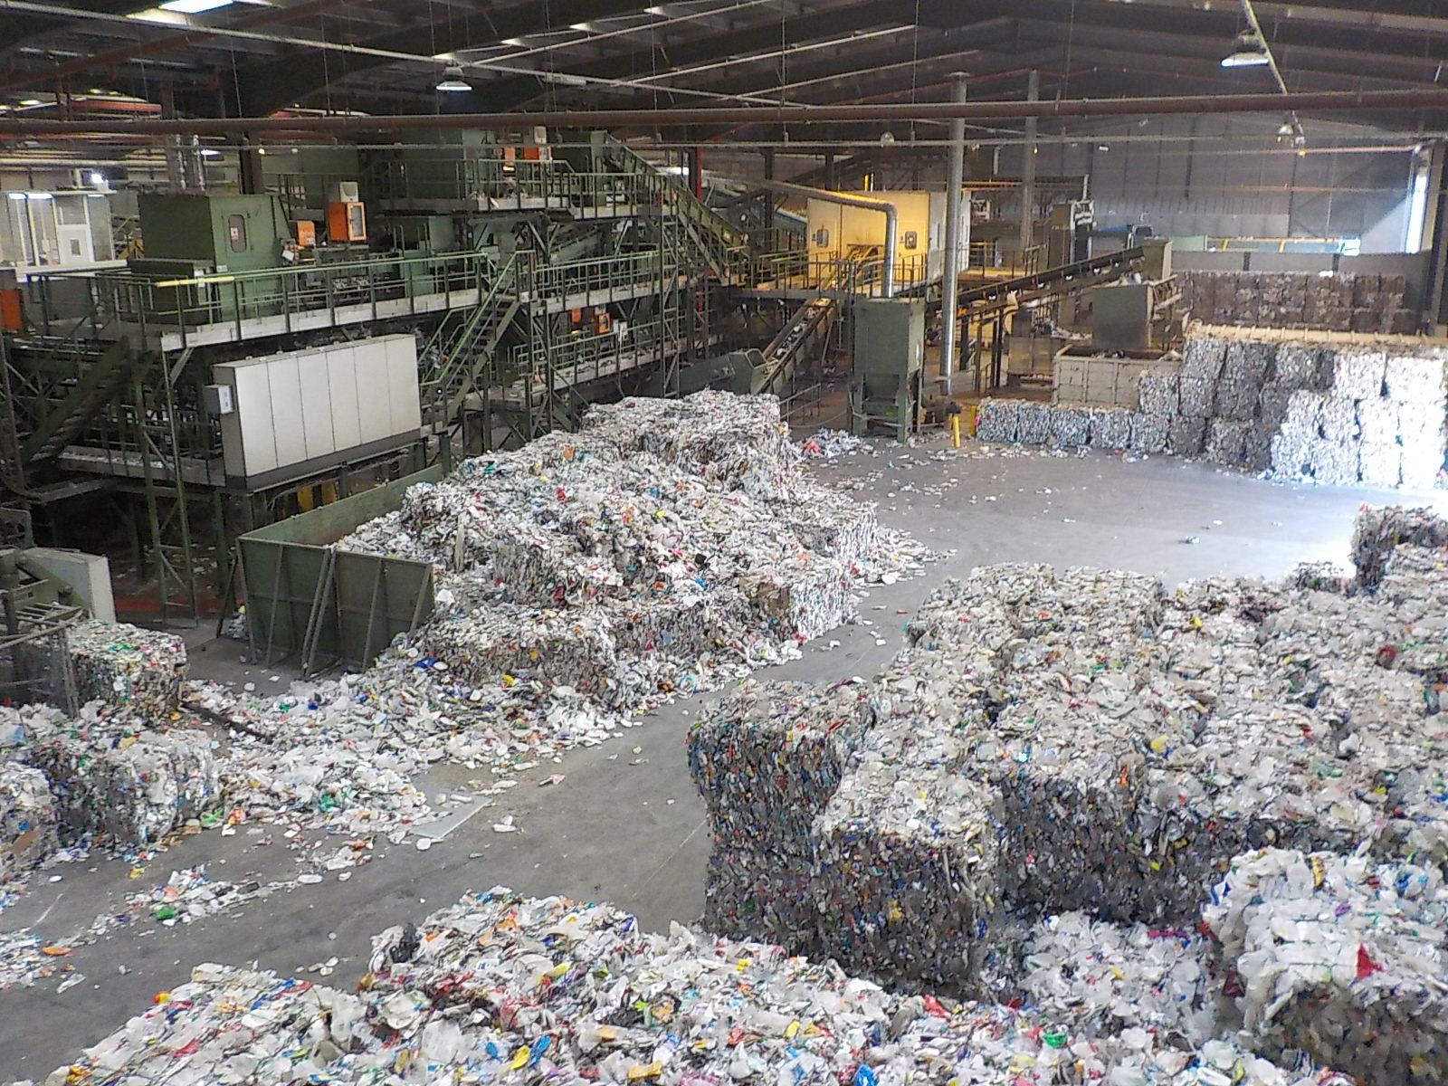

The table below shows you what students will be covering throughout this term in their core subjects;
Maths | In Maths this term students will be focusing on the key Number aspect of fractions and linking to the Entry Level qualification. We will also be covering the topic of geometry and focusing on using mathematical language to describe the position and direction of objects. In addition we will be practicing examination papers.
English | In English 4.2 will be completing exam practise and focusing on the basic skills of reading, writing, answering questions.
Science | In Science students will be looking closely at how some reactions transfer energy to the surroundings so the temperature increases and how other reactions take in energy from the surroundings, so the temperature decreases. This investigation will form part of their coursework.
Cookery | In this lesson 4.2will be completing their BTEC level 1 whilst cooking a variety of dishes including some Easter themed dishes.
DT | Students are now following the OCN course in craft skills. This term they will be designing and building their own product out of wood or plastic.
PE | Students will be team skills as well as learning a new activity through hockey.
JASS | During this lesson students will be continuing to complete components for the Silver Award. We will be finishing the ‘Me and My World’ section where we have focused on plastics pollution and recycling. We will then move on to ‘Get Active, Stay Active’ and look at learning a new activity.
ICT | This half term students will be focusing on the skills required for their Entry Level examination by extracting and sending information.

In addition to the above subjects students will be starting a vocational option of either Art, Horticulture, Sports Leader or Catering.

We are also getting ever closer to examination time and I fully appreciate this a time which many struggle with. Before the holiday they underwent some testing to ensure we can provide each pupil with as much support during the exams. We will be completing mock examinations in the next few weeks and these will be run as they will be in May/June. Hopefully this will help alleviate some of their concerns and together we can deal with any anxieties that may arise. Later this year your child will complete their final examinations so can I reinforce the importance of attendance to ensure that vital work is not missed.

We will continue to have a whole school assembly on a Monday morning with the focus being on celebrating good work and achievements. Therefore if your child has anything to be celebrated please put a note into the diary.

It has been wonderful to see a significant improvement in uniform being worn by all in key stage 4 recently. So, can I thank you for your support in ensuring your child attends school in the correct uniform and brings the correct PE kit on Mondays.

Should you have any queries or concerns then please do not hesitate to contact either myself or Mrs Giles.

Yours sincerely

Mrs Niki Byrne (Class Teacher)
Mrs Louisa Giles (Class TA)

