Oak Newsletter 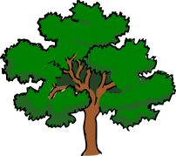

Our topic this term is Traditional Tales. We will be writing Traditional Tales with a Twist and making up our own senses poetry. In Maths we will be continuing our number work and also be learning about shapes and patterns and measuring length.
Exciting news for our PE lessons – we are having a Tennis coach to come and teach us some Tennis skills – watch out Andy Murray!! In Humanities we are learning about the Victorians and will be comparing our lives at school to those on The Victorian era. I am hoping to incorporate an educational visit into this topic so keep your eyes open for further news.
Our Science topic is dissolving and we have some interesting experiments lined up. Also we’re hoping to create a little treat for our Mums and carers with Mother’s Day coming up!!
Year 6 will continue to go swimming for the next 4 weeks and the children who stay at school will be continue to join Beech class for PSHE work about emotions and friendships.
Unfortunately Michelle is off at the moment but is being covered by Mrs Rainbow so that the children have consistency.
Please continue to contact us through the diary if you have any questions or want to tell us about what you’ve been up to at home.
Thank you for your continued support.
Oak Class

