Oak Newsletter 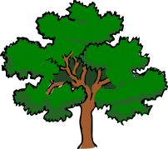

Our topic this term is In the Wild. We will be writing adventure stories and learning some animal poetry. We have been busy practising our Jack and The Beanstalk play and would like to invite you to a performance on Friday 8th February at 1.30 p.m.
PE is gymnastics this term and in Humanities we are learning about explorers including Christopher Columbus. Our Science topic is Seasonal changes and we have already made rain gauges to collect some weather data. In Maths we are learning about Weight and Capacity and we are also making pictograms and bar charts and learning how to get information from them.
Year 6 will continue to go swimming and the children who stay at school will be joining Beech class for some PSHE work about emotions and friendships.
Please continue to contact us through the diary if you have any questions or want to tell us about what you’ve been up to at home.

Jayne, Vanessa, Michelle and Katie

