**Wednesday** – forest school

**Friday** – PE

We will be sending homework and reading books home every Friday. Please could these be returned on Monday’s as children can show their work in assembly if they wish. If you could read with your child and do their homework at some point over the weekend that would be great.

Friday afternoons will focus on mental health and wellbeing. The aim is to make this as fun as possible for the children. It may include mindfulness activities, healthy eating and socialising.

.

Literacy – Fiction Stories with familiar settings and Poetry linked to senses

PSHE – Health and wellbeing

Maths – Geometry (properties of shape/Patterns and Measure (Length).

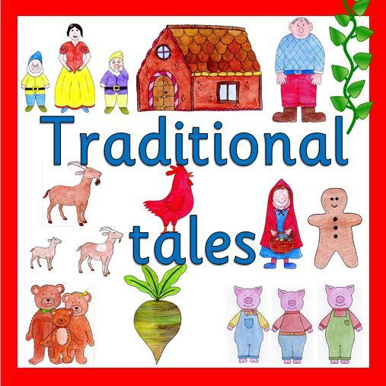

Humanities – The Victorians

Design Technology– Themed work

Art & design – 2D observational art and Van Gogh

ICT – Computing skills/ Coding

Science – Properties and changes of materials

PE – Outdoor and adventurous activities