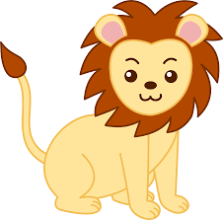

Spring 1 Class Newsletter

Dear Parents and Carers,

Happy New Year! Thank you for all your lovely cards and gifts. We hope you all had a wonderful Christmas.

This half term our theme is ‘In the Wild’. We will be basing our learning around the books: Dear Zoo, Giraffes Can’t Dance, Rumble in the Jungle and Slowly, Slowly, Slowly said the Sloth. We are going to be working on joining in with repetitive elements within stories, as well as looking at non-fiction texts in Literacy, finding out information about animals. In Maths, we will be learning about pattern by recognising animal patterns and patterns around us, as well as copying and creating our own patterns using resources. We will also be learning about size, recognising and naming big, medium and small objects, as well as ordering a few objects by their size.

In other areas of learning, we will be learning about Chinese New Year and Valentine’s Day, engaging in class based celebrations around these. In PE we are learning how to move our bodies like different animals in dance, and we will also be developing our art skills by creating models of animals.

Many thanks,
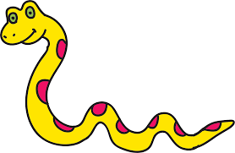
Saplings Class Team

