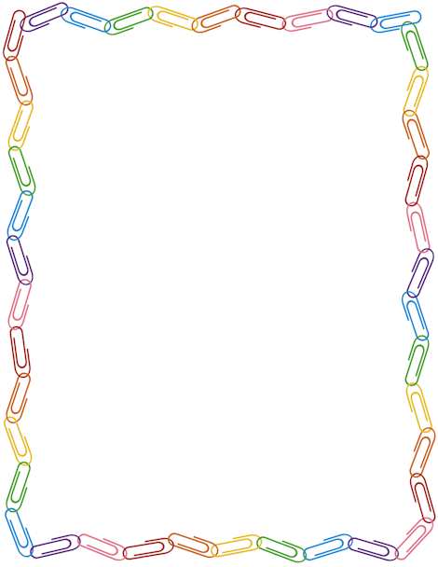
3.2 Newsletter – January 2019
We hope you had a relaxing Christmas break and enjoyed celebrating the New Year.
Last half term 3.2 had the opportunity to take part in a ‘Mad Science’ event, they worked very hard programming the school BeeBots in our computing lessons and took part in the Christingle service at St Godwalds. We enjoyed preparing for Christmas by doing lots of crafts and activities and the class secret santa was a big hit so thank you to all involved!
Please see below some of the topics that we will be studying this upcoming half term. A copy of the student timetable can be found in the home/school diary.

English | Fiction – William Shakespeare  Poetry – rhyming with repetitive language/performance poetry
Maths | Number – addition and subtraction  Geometry – Position and direction  Measure – Length and temperature
Science | Particle models – elements and atoms  *taught by Mrs D. Walker
Computing | Multimedia: eBooks
Art | Animation
Music | Elgar
Humanities | History – Cromwell  Geography – Climate change over time
PSHE & Citizenship | PSHE – Personal safety  Citizenship – Judicial Law  *taught by Miss T. Deooray
P.E. | Health and fitness
Religious Education | What times special to me?
Design Technology and Cooking | iPod Generation  Skills, fruits and vegetables  *taught by Mr T. Moyle & Mrs K. Cooper
MFL | French – animals

Homework – please encourage your son/daughter to set aside time each evening to complete homework tasks/reading. However, please remember that the homework tasks are not mandatory.
Reminders – everyday students must wear correct school uniform and bring the correct equipment for the day including their home/school diary.
PE - Please ensure that your son/daughter has their full PE kit every Wednesday.
All the best,
Miss M. Gee

