Oak’s Newsletter
Autumn 1

This is Mrs Ferran, Oak’s teacher.
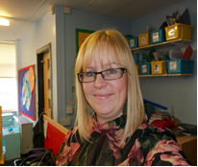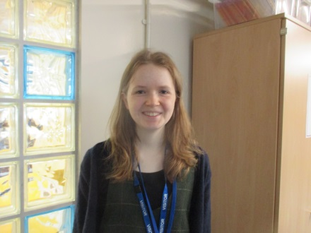
This is Miss Weller. Miss Weller is learning to be a teacher and will be helping us lots this year!
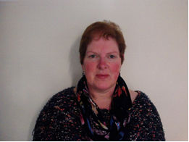
Welcome back!
This is Mrs Baker, Oak’s teaching assistant.

- Our first exciting topic is Superheroes! Up, up and away!
- Maths: We are learning about number, position and direction. We could count lots of items at home for extra practise or count on or back from any number.
- Literacy: We will be writing lots about superheroes and making up our own stories, could we practice re-telling or making up our own stories at home.
- Humanities: We are learning about different countries and what they eat.
- Science: we are learning about pushes and pulls.
- PSHE: We are learning how to be a ‘good friend’ and bullying.
- ICT: We are learning how to be safe on the computer.
We need to remember - P.e kit will stay in school and be sent home every half-term
Tuesday | - P.e is outside so we will need tracksuits and warm P.e clothes. P.e kit to stay in school.  - Swimming kit.
Wednesday | - P.e. kit. P.e kit to stay in school.
Thursday | - Home reading books, we will change these every Thursday.  - Forest School kit.

