|  |
| --- |
| New Logo |
|  |

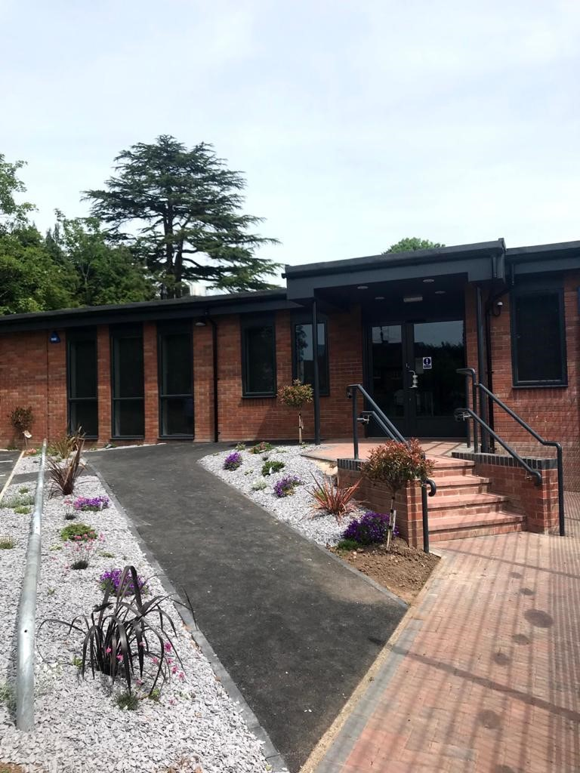

Dear Applicant

Thank you for your interest in the advertised post of Receptionist / Administration Assistant at Rigby Hall School.

Rigby Hall is a mixed community day special school catering for students aged 4-19 who have a learning disability as their primary difficulty, many of who also have associated sensory or communication difficulties. Over the past few years, the difficulties our pupils are displaying are more complex in terms of behaviours and the severity of these.

The pupils’ attainment on entry to the school is well below age-related expectations. Pupils are placed at the school with an Education, Health and Care Plan (EHCP). Pupils are referred from across the age range coming from mainstream nurseries, first, middle and high schools. Some pupils are referred from assessment nurseries.

There has been a gradual increase in the number of pupils diagnosed with ASD/sensory and communication difficulties. We do have a small number of students who are nonverbal.

The school is rapidly growing and our expansion in numbers has led to the creation of a Complex needs centre, opened in September 2019 and restructure of the main hub of the school, opened in March 2019. The school currently comprises of six Primary classes, four Key Stage 3, two Key Stage 4 and a Post 16 Centre. The school has a separate gym – recently refurbished, DT and Food Tech rooms, Science lab, an IT suite and Forest School. In September 2020 we opened our Life skills village comprising of a fitness suite, Hair 7 Beauty Salon, Construction cabin, car maintenance and a fully functioning flat. Our pupils have access to daily mile track on our back field.

Our playground has been updated and improved in consultation with the pupils, and we have a MUGA on the bottom playground reflecting our vibrant and energetic atmosphere within school.

The school is situated on the eastern outskirts of Bromsgrove near to the town railway station and is readily accessible from the M5 and M42 motorways.

Governors, Senior Leaders and Staff have a clear vision of our future. Our vision builds on our strengths and encompasses the development of a cohesive special school; confident, vibrant, outward looking with active mainstream staff/pupil links, responsive to changes in the educational environment and offering children and parents a positive choice.Expertise of our staff and continuous training, ensures high quality learning experiences and opportunities for our pupils.

The curriculum is practical, cohesive and creative, focusing on the developments of key skills at key stages, ensuring each child reaches their full potential. We have a thematic approach across the school. Pupils in KS3 – 5 concentrate on work related learning and vocational opportunities together with accredited courses.

Please see our new website for further information about the school and what we offer.

Rigby Hall is committed to safeguarding and promoting the welfare of children and young people and expects all staff and volunteers to share this commitment. This post is subject to an enhanced DBS check.

Currently visits are difficult to cater for, so please keep up to date with our website.

**Closing date for applications: Noon Tuesday 4th October 2022**

**Interviews will be held: Week commencing Monday 10th October 2022**

Yours sincerely



Mrs T Smith

Headteacher